Multimedia Presentations
Below, read a passage from the realistic fiction story, “The Forest of Quaking Trees.”

After finishing lunch, Christina said, “Okay, now our treat!”
Mrs. Ramos laughed. “We’ll have to head to a grill for it.”
“It is s’mores!” Christina said, and even Yamila smiled at that. And it was a genuine smile.
“You girls go ahead, and we’ll meet you there,” Mr. Ramos said.
Yamila and Christina headed to the nearby picnic area and sat at the table. Yamila slapped at a bug that threatened to land on her and shivered. “Man, I hate bugs.”
“We need bugs,” Christina said.
“You might need bugs, but I can go the rest of my life never seeing another one.”
“You need bugs too,” Christina insisted.
“For what? To bite me and leave me itchy?”
Christina shook her head. “For all of this.” She spread her arms wide, indicating the grass and the woods. “Don’t look at me that way. It’s true. Without bugs, we wouldn’t have flowers, or trees, or even food.”
“Or malaria, or Lyme disease, or—”
“You’re impossible,” Christina said, but giggled despite herself.
A man and his daughter, who appeared to be about Yamila’s age, sat down at another table with their lunch just as Mr. and Mrs. Ramos joined their daughters. “Good afternoon,” Mr. Ramos called out and waved.
“Afternoon,” the man waved back.
“We should invite them for s’mores,” Christina said.
“I don’t know; we might not have enough,” Yamila said, eyeing the supplies greedily.
“Go ahead and ask,” Mrs. Ramos said. “We have plenty.”
Christina skipped off, and a moment later Yamila noticed the girl’s head shooting up in their direction—and then she grinned.
“Guess they like s’mores,” Yamila mumbled as the man and his daughter approached their table.
“Thanks for your kind invitation,” the man said. “My name’s Horace Bailey, and this is my daughter, Tamera.”
Mr. Ramos introduced his family, and then the adults started preparing the s’mores.
“So where are you folks from?” Mr. Bailey asked.
“Nevada,” Mrs. Ramos said. “And you?”

Now look at the chart below to see what we learn about the story’s meaning, tone, and beauty from just reading the words.

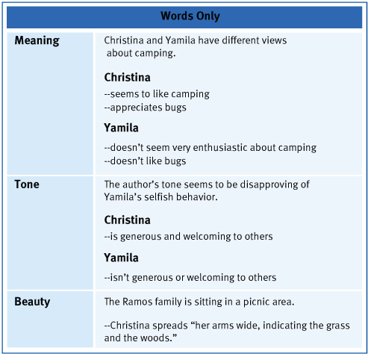

Now let’s look at a multimedia presentation of the same passage from the story. Look at the pictures and be sure to click the play button above each page, in order to hear the words read aloud as you follow along.

TEACHER PLAYS AUDIO PRESENTATION OF THE STORY.

Now let’s see how the story’s pictures and the sound of the words read aloud contribute to the story’s meaning, tone, and beauty.

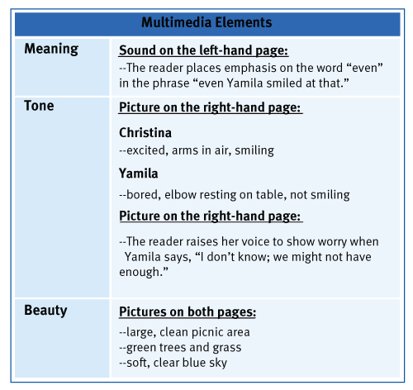
How do the multimedia elements contribute to the story’s meaning?

How do the multimedia elements contribute to the author’s tone?

How do the multimedia elements contribute to the story’s meaning?

