Analyze Visual and Multimedia Content
Imagine a story that is told through pictures and words. Now imagine that the pictures are arranged on the page in sequential panels like they are in a comic book. The words appear in speech bubbles or in text boxes. Suppose, too, that the story isn’t just about a superhero, but about an event in history or a fantasy world or something else entirely. Adults as well as children enjoy this kind of story. So what kind of story are we talking about?
A graphic novel! In a graphic novel, the pictures and the words work together to tell the story. The pictures are essential to the narrative. Without them, there is no “story.” This is not necessarily the case in other kinds of stories.
For example, if someone gave you a book that happened to contain pictures and you decided to just read the words, would you be able to tell what the story meant? Would you be able to identify the author’s tone, or attitude toward the subject? Would you be able to appreciate the story’s beauty? You probably would.
However, if you also looked at the pictures and heard someone read the words aloud, you might better understand and appreciate the story. You could witness on the page the beautiful scenes of a tale set in the Old West. You could hear your teacher demonstrate how to whisper so quietly that even a sleeping giant wouldn’t wake!
Let’s look at the following graphic novel.

Graphic Novel
Below, you will read a graphic novel. This graphic novel is a myth about how the Greek god Prometheus gave fire to human beings. The story is told on two pages. You should read each panel on the page from left to right, starting at the top.
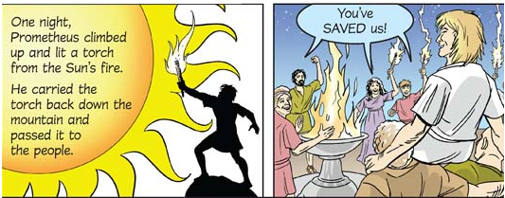
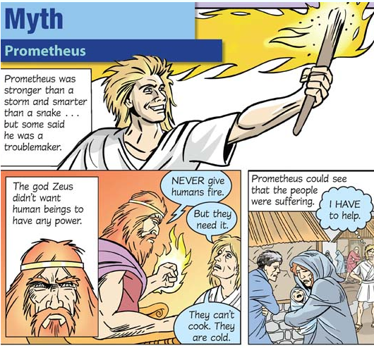

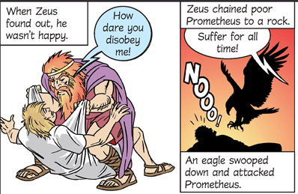
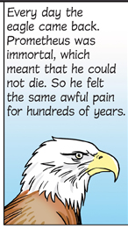
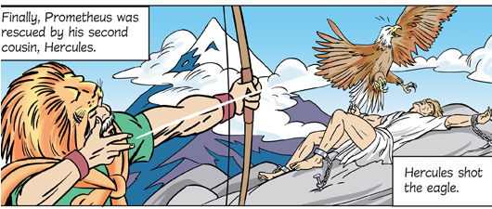
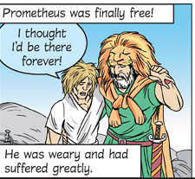
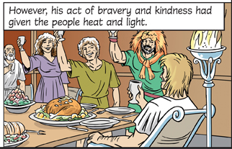

Now let’s analyze how the pictures and the words work together to help us understand the meaning, tone, and beauty of the story.

Meaning
Take a look at the first two panels. Panel 1 on the top of the page tells who Prometheus is and shows what he looks like. Panel 2 tells who Zeus is and what he looks like. It also shows a conversation between Prometheus and Zeus. Are Prometheus and Zeus alike or different?
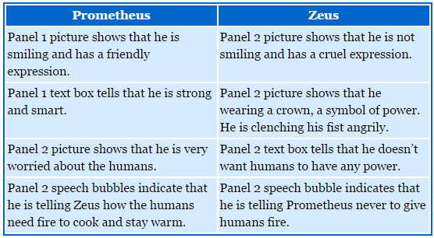

From the interaction between the pictures and the words, we can tell that Prometheus and Zeus are very different characters. Prometheus is kind and feels pity for the humans. Zeus is cruel and has no sympathy for them.
- The text boxes and the pictures work together to tell the story. They tell and show who the characters are and what events are happening. Sometimes the text boxes also advance the story’s plot by providing additional information.
- The speech bubbles and the pictures also work together to tell the story. The speech bubbles contain the characters’ dialogue. Each one points to the character in the picture who is speaking. If a word appears in all capital letters, it means that this word is spoken very forcefully. For example, Zeus tells Prometheus NEVER to give fire to humans.

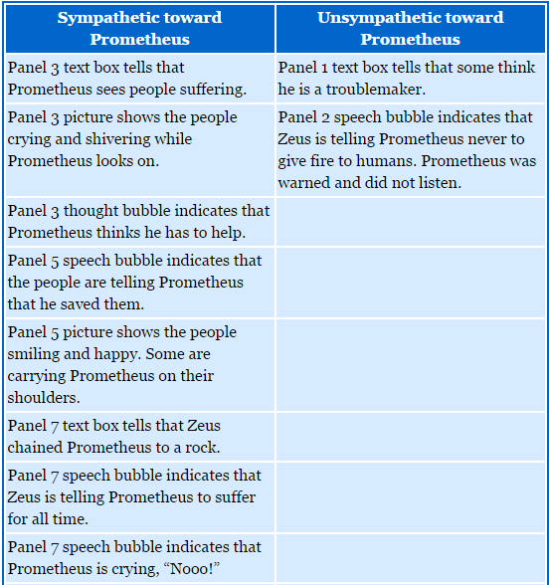
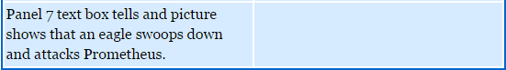
Tone
Now let’s see how the pictures and words work together to help us understand the author’s tone, or attitude toward Prometheus’s behavior. Is the author sympathetic or unsympathetic toward Prometheus?

From the interaction between the pictures and the words, we can tell that the author is sympathetic to Prometheus’s behavior. Prometheus disobeys Zeus’s command because he feels sorry for the people and wants to help them. The punishment he receives for disobeying, especially when his intentions were good, is very harsh. The author seems to agree with the people that Prometheus is a hero.

Beauty
Now let’s see how the pictures and words work together to help us understand the story’s beauty.
Panel 4 tells and shows how Prometheus climbs to the top of a mountain and lights a torch from the sun’s fire. This is a very noble and majestic act. In Panel 5, we see what a difference this makes to the people. The people are laughing and happy instead of miserable and shivering, as they are in Panel 3. The last two panels tell and show how much Prometheus suffers for the action of giving people heat and light. The sacrifice Prometheus makes for others is what gives this story its beauty.

